## Input and Output

Figure 5.1: **Original Image** **(Before Dehazing)**

Figure 5.1 is the original footage captured by an autonomous vehicle’s camera and is heavily obscured by fog. Essential details like nearby vehicles and lane markings are indistinct, which reduces the vehicle's ability to detect objects and navigate safely.

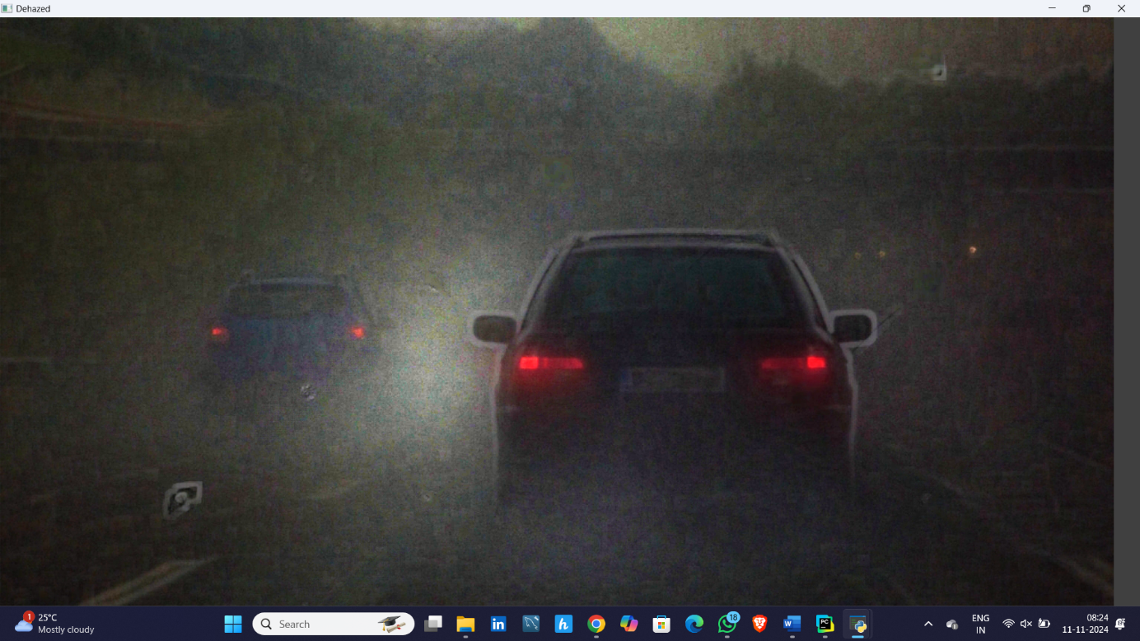

Figure 5.2: **Dehazed Image (After Applying Dark Channel Prior Technique)**

After applying the dehazing algorithm, the image clarity improves significantly, making the car ahead and other visual elements much clearer. This enhancement enables computer vision systems to detect vehicles, obstacles, and lanes accurately, even in poor visibility.

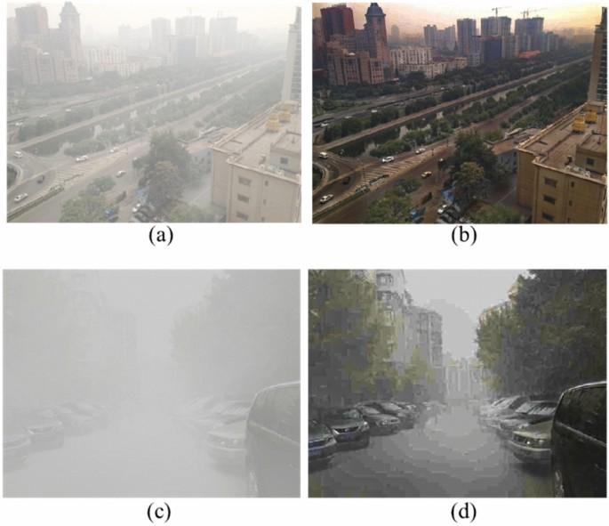

Figure 5.3: **Original Image** **(Before Dehazing)**

Figure 5.3 is a drone-captured urban scene, heavily obscured by haze. Essential details like roads and buildings are indistinct, reducing the reliability of drones in surveillance or mapping applications under adverse conditions.



Figure 5.4: **Dehazed Image (After Applying Dark Channel Prior Technique)**

In Figure 5.4, the dehazing algorithm significantly improves visibility, making structures and roads clear. This enhancement enables drones to capture more accurate visuals, essential for monitoring and data collection in low-visibility situations.



Figure 5.5: **Original Image** **(Before Dehazing)**

Figure 5.5 is the original, foggy scene captured by the CCTV camera, vehicles and street details are barely visible due to heavy fog. This lack of visibility is a major challenge for surveillance, making it difficult to identify objects or track movement accurately.



Figure 5.6: **Dehazed Image (After Applying Dark Channel Prior Technique)**

After applying the dehazing technique, the visibility improves significantly, with cars and buildings becoming more distinct. This enhancement enables CCTV systems to perform more reliable monitoring and object detection, even in poor weather conditions, improving overall security effectiveness.